**A**



**Practical Assignment**

**Of**

**New Age Life Skills**

**B.Tech(CSE)AI&ML(IBM)**

**SEMESTER - 1**

**RUNGTA INTERNATIONAL SKILLS UNIVERSITY**

**SESSION: 2025-26**

**Submitted To:- Submitted By:-**

**Ms. Priya Das Sameer Kumar**

**RU-25-11271**

**Section= 1-B**

**Submitted To:**

**RUNGTA INTERNATIONAL SKILLS UNIVERSITY,CG**

**SCHOOL OF INFORMATION TECHNOLOGY**

|  |  |  |  |
| --- | --- | --- | --- |
| **S.No** | **Name Of Practical**  **INDEX** | **Submisson Date** | **Remark** |
| **1.** | **Design a professional resume using templates.** | **22-09-2025** |  |
| **2.** | **Create a Career Oriented Presentation with 7 slides using transitions and animations.** | **29-09-2025** |  |
| **3.** | **Create a social media poster for “DIGITAL AWARENESS WEEK” using canva.** | **01-10-2025** |  |
| **4.** | **Compose & send a professional email with an attachment as “you are applying for an internship, send email to HR with your resume attached”.** | **06-10-2025** |  |
| **5.** | **Design a complete Google Form survey and analyze responses.**   1. **Create a Google Form titled “Student Attendence Report”.** 2. **Include the following question types:**    1. **5 MCQs**    2. **1 Rating scale (1–5)**    3. **1 Short answer**    4. **1 Checkbox question** 3. **Customize the theme (header image + color).** 4. **Share the form link with 5 friends and collect responses.** 5. **Generate charts from responses and take screenshots of the analysis page.** | **11-10-2025** |  |
| **6.** | **Demonstrate the creation and management of your digital identity.**   1. **Create a social media profile (LinkedIn preferred).** 2. **Add a profile photo, short bio, skills, and education details.** 3. **Create a simple post about “My Learning Journey in Digital Literacy.”** 4. **Change your privacy settings to:**    1. **Who can see your posts.**    2. **Who can message you** | **31-10-2025** |  |
| **7.** | **Using Google Drive or OneDrive:**   1. **Create a new folder named “Unit 3 Practical Work”.** 2. **Upload 3 different files (PDF, image, document).** 3. **Organize them in subfolders: Notes, Images, Assignments.** 4. **Share the main folder with your teacher with View Only permission.** | **13-11-2025** |  |
| **8.** | **Identify one real phishing email** **: A final-year student, Aman, receives a LinkedIn message saying:**  **“You are shortlisted for a Remote Software Developer role at Google.**  **Salary: ₹18 LPA.**  **Pay ₹2,499 as verification fee.**  **Limited seats. Pay now to confirm.”**  **ANSWER THE QUESTIONS :-**   1. **What type of cybercrime is happening here?** 2. **List** 3 red flags **that show it is a scam?** 3. **What should he do to verify if a job offer is real?** | **19-11-2025** |  |
| **9.** | **Create a Google Form Quiz with the following requirements:**   1. **Convert the form into a Quiz mode with automatic grading.** 2. **Add 5 MCQ questions, each carrying 2 marks.** 3. **Add 1 short answer question that requires manual evaluation.** 4. **Turn ON the setting:**    1. ***Limit to 1 response***    2. ***Shuffle question order***    3. ***Release marks after manual review*** 5. **Add a timer add-on (like form presenter) and set up a 10-minute time limit.** 6. **Finally, send the quiz link and view the response summary.** | **24-11-2025** |  |
| **10.** | **Ask ChatGPT OR Google Gemini to generate a 100–120 word paragraph on:**  **“Is online learning better than offline learning for college students?”**   * + 1. **Run the AI-generated text through Grammarly and any plagiarism-check tool.**     2. **Now manually search online to check if similar sentences exist on blogs or articles.**     3. **Identify 2–3 biased statements in the AI answer, such as:**        - 1. **Over-generalizations**          2. **One-sided opinions**          3. **Unproven claims**     4. **Rewrite the entire paragraph in a neutral and balanced way, using AI only for grammar suggestions.**     5. **Submit 3 screenshots:**  1. **Plagiarism check result** 2. **Grammarly suggestion page** 3. **Original AI paragraph vs your rewritten unbiased version** | **29-11-2025** |  |
| **11.** | **To compare AI-generated content with student-created content and understand limitations of AI.**   1. **Write a 100–150 word paragraph on the topic: “Will AI replace jobs or change them?” (This must be written by the student.)** 2. **Ask any AI tool (ChatGPT/Gemini/Copilot) to write the same topic.** 3. **In your practical copy, create a Comparison Table with the headings:** 4. **Human-Generated Content** 5. **AI-Generated Content** | **03-12-2025** |  |
| **12.** | **Create a new NotebookLM project titled: “My Chapter Revision Notes.”**   1. **Upload multiple sources (any 2) such as:**    * 1. **PDF notes**      2. **Web articles**      3. **Text copied into NotebookLM** 2. **Ask NotebookLM to:**    * 1. **Create a combined study guide using all sources.**      2. **Generate flashcards for quick revision.**      3. **Create a concept map or explanation of the topic.** 3. **Manually check for:**    * 1. **Any incorrect facts**      2. **Repeated information**      3. **Missing important points** 4. **Attach 3 screenshots from NotebookLM:**    * 1. **Combined study guide**      2. **Flashcards**      3. **Concept map / explanation** | **10-12-2025** |  |
| **13.** | 1. **Create a complete Student Result Management workbook.** 2. **Create a new workbook with 3 sheets renamed as:**    1. ***Student_Data***    2. ***Marks_Analysis***    3. ***Charts*** 3. **In *Student_Data*, enter a list of 15 students with: Name, Roll No, Class, City, Subject1, Subject2, Subject3.** 4. **Use Flash Fill to split “Full Name” into “First Name” and “Last Name”.** 5. **Use Find & Replace to replace city name “Delhii” with correct “Delhi”.** 6. **Use IF function to calculate Pass/Fail (Pass = total ≥ 120).** 7. **Use COUNTIF to find how many students belong to “Delhi”.** 8. **Use AVERAGE, MAX, MIN to analyze marks in the *Marks_Analysis* sheet.** 9. **On the *Charts* sheet, create:**    * 1. **A Bar Chart showing marks of any one subject.**      2. **A Pie Chart showing percentage of pass vs fail.** 10. **Apply Conditional Formatting to highlight marks < 40 in red.** 11. **Convert the table into a formatted Excel Table.** | **19-12-2025** |  |
| **14.** | **Build a workbook for managing and analyzing sales data of a small store.**   1. **Create a workbook with sheets:**    1. ***Store_Sales***    2. ***Summary***    3. ***Charts*** 2. **Import a CSV sales file (or create a sample table) containing: Date, Product, Category, Quantity, Price, Total Sales.** 3. **Use Sort (A→Z, Z→A) to organize products by name and category.** 4. **Apply Filter to view only “Electronics” category.** 5. **Use SUMIF to find total sales for a selected product (e.g., “Headphones”).** 6. **Use LEFT, RIGHT, MID to extract:**    1. **First 3 letters of the product name**    2. **Last 2 letters of the category** 7. **Find the highest and lowest sales value using MAX/MIN.** 8. **Prepare a monthly sales summary in the *Summary* sheet using AVERAGE & SUM.** 9. **Create a Line Chart of month-wise total sales in the *Charts* sheet.** 10. **Apply sheet protection so data cannot be edited accidentally.** | **24-12-2025** |  |
| **15.** | **Create a complete personal financial planner workbook.**   1. **Create and rename sheets as:**    1. ***Expenses***    2. ***Budget***    3. ***Charts*** 2. **Enter at least 20 rows of expense data: Date, Category, Expense Detail, Amount, Payment Method.** 3. **Use Data Validation dropdown to create a category list (Food, Travel, Fees, Shopping, Other).** 4. **Use Remove Duplicates on the Category column if repeated incorrectly.** 5. **Use SUMIF to calculate total spending for each category.** 6. **In the *Budget* sheet, create the monthly budget and compare with actual expenses using:**   **Difference = Budget – Actual (formula required)**   1. **Highlight expenses above ₹2000 using Conditional Formatting.** 2. **Create:** 3. **A Pie Chart showing category-wise spending** 4. **A Bar Chart comparing *Budget vs Actual*** 5. **Use Flash Fill to separate date into Day / Month / Year if needed. Also explain its detail** 6. **Save worksheet in Page Layout view and adjust print area.** | **29-12-2025** |  |

**Practical – 1**

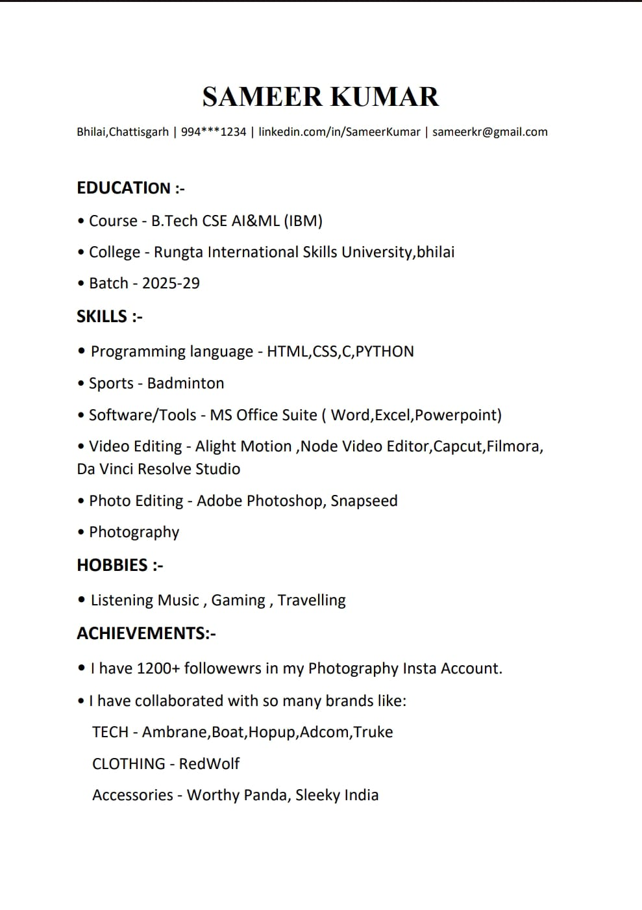

**Practical – 2**

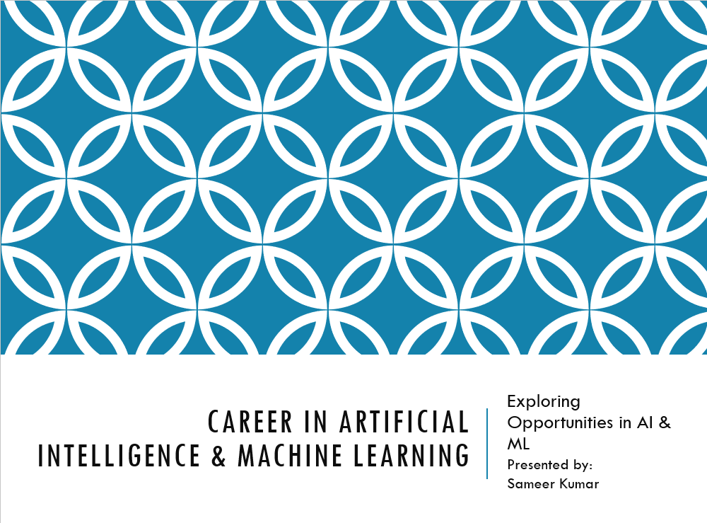

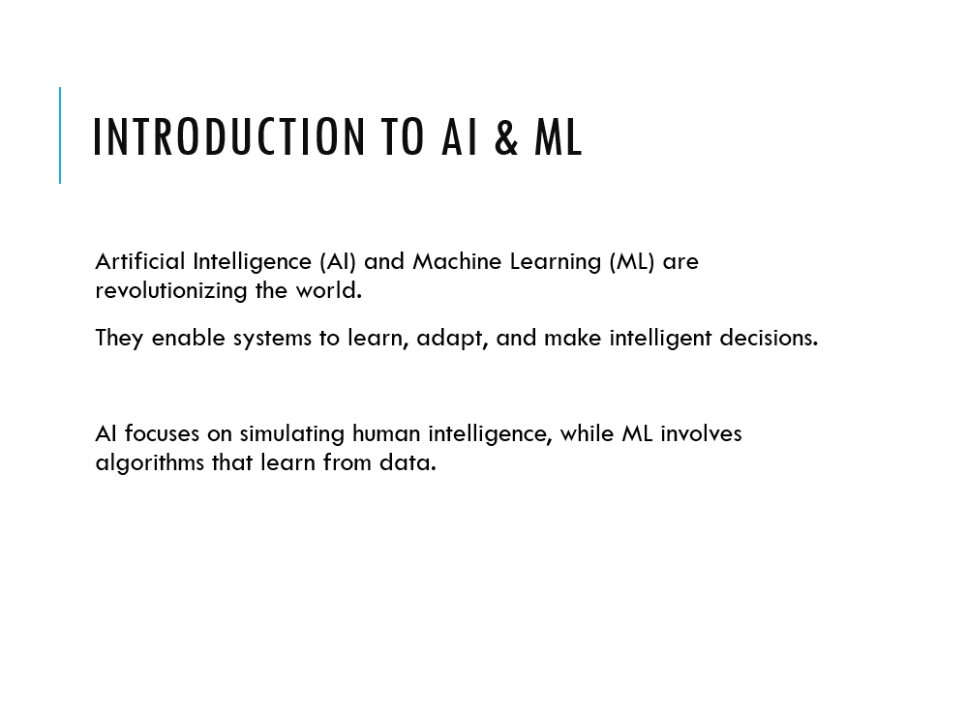

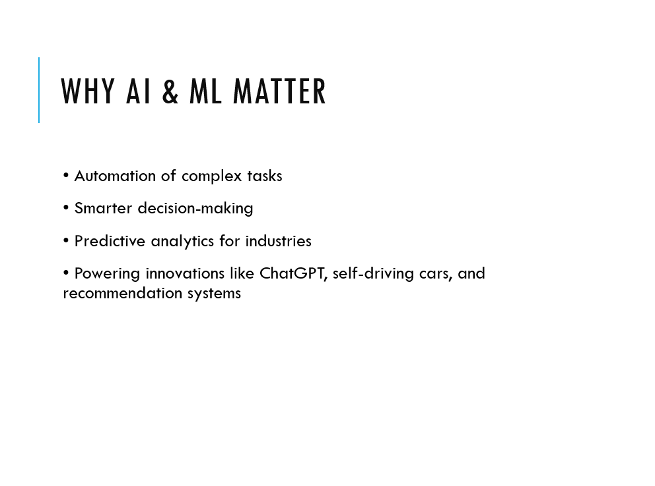

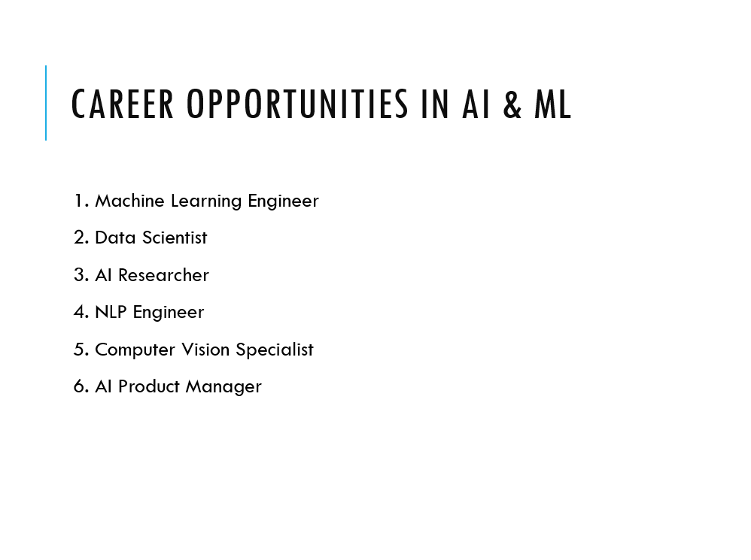

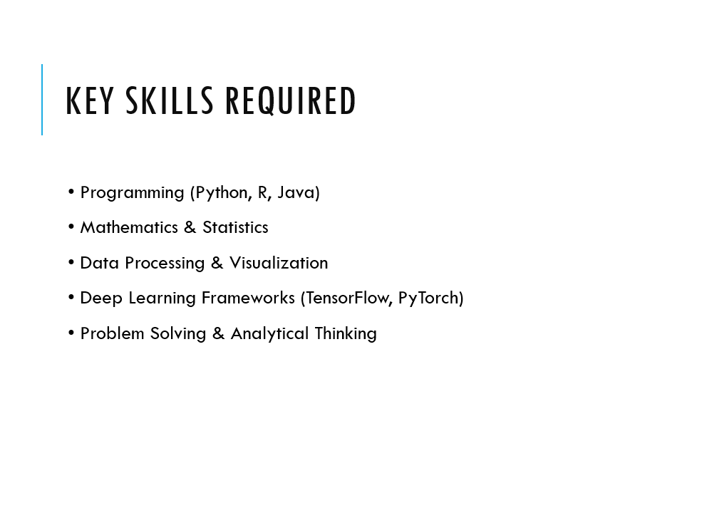

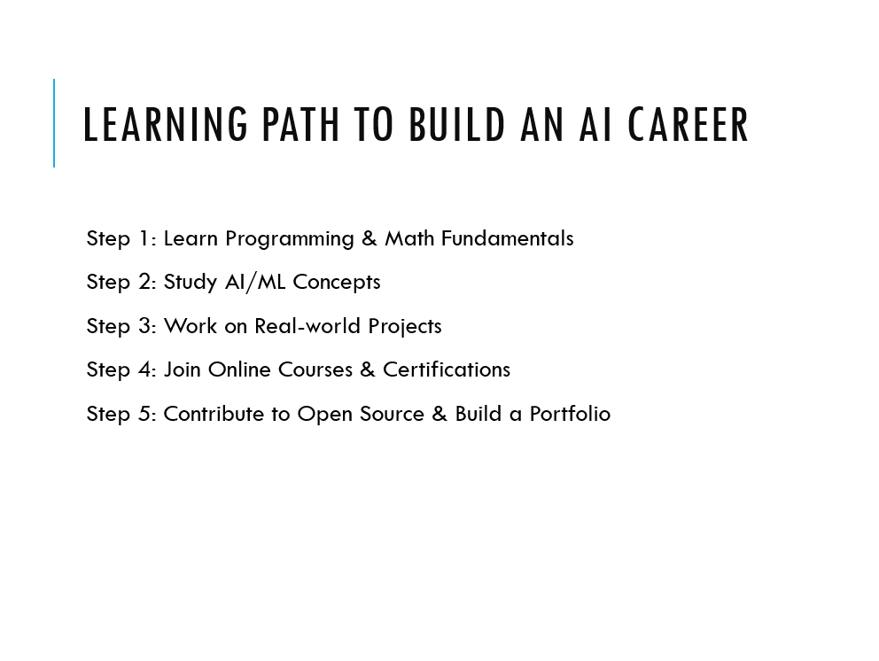

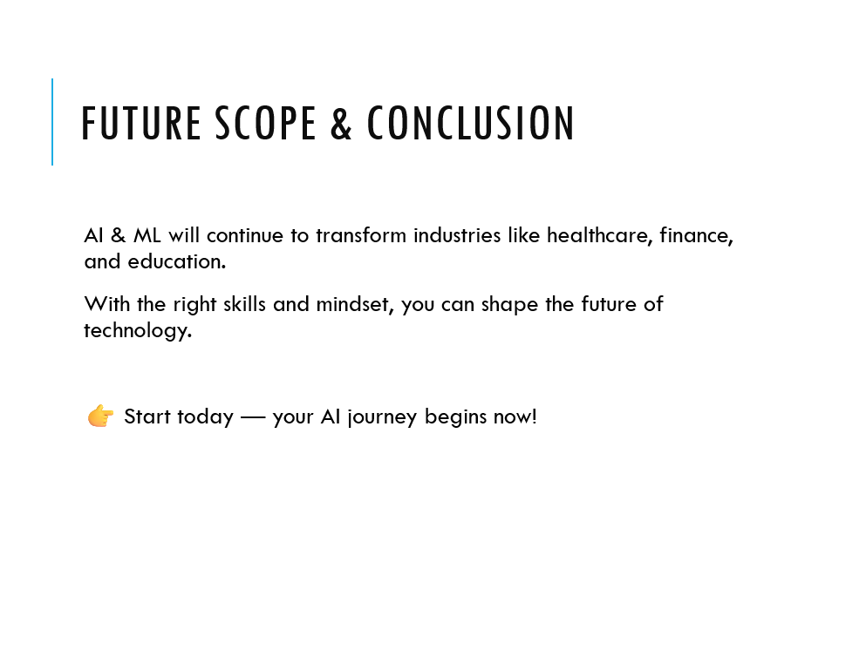

**Practical – 3**

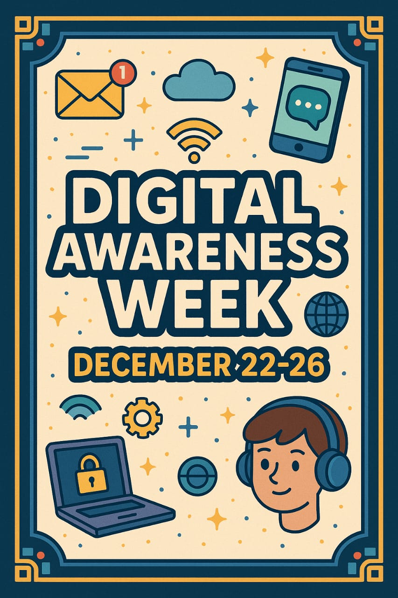

**Practical – 4**

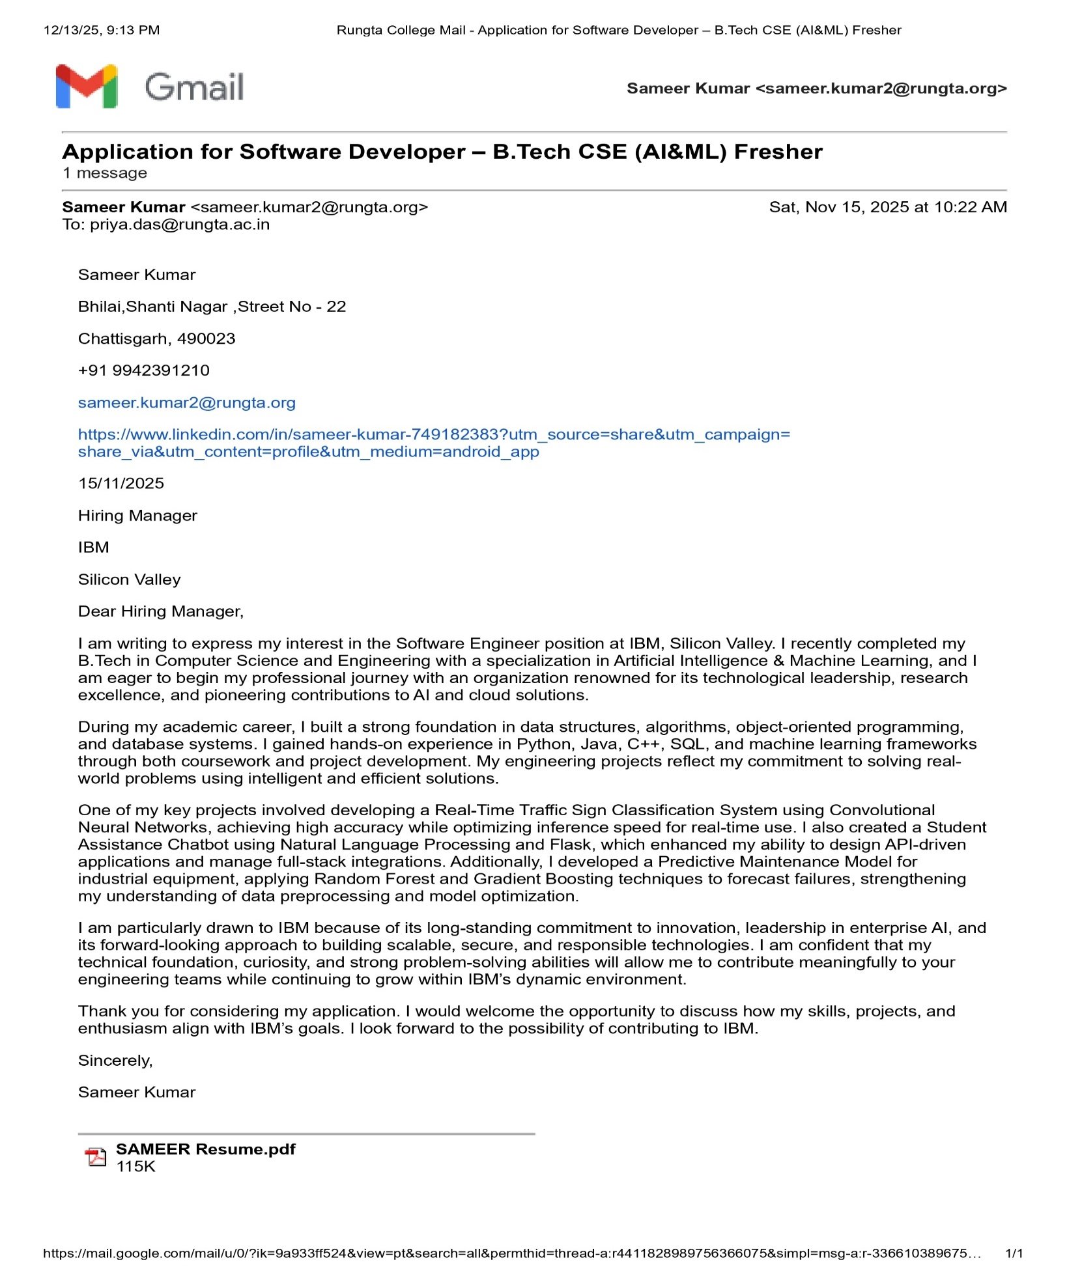

**Practical – 5**

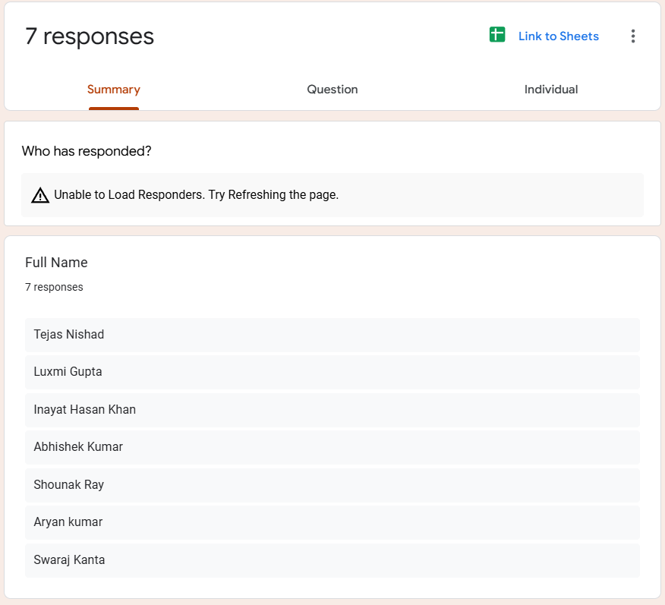

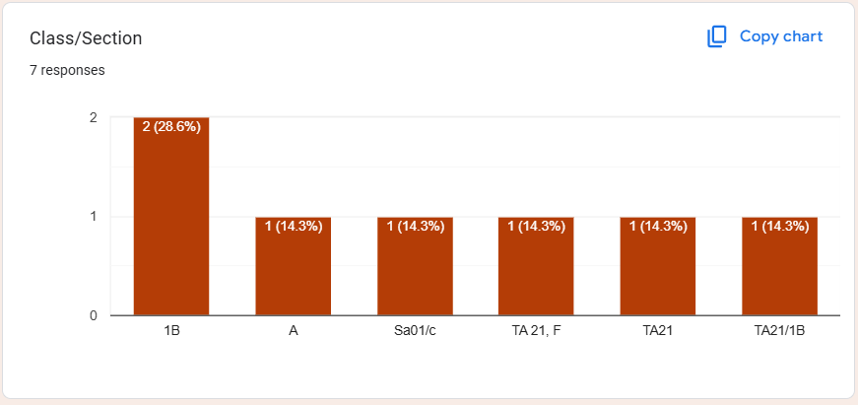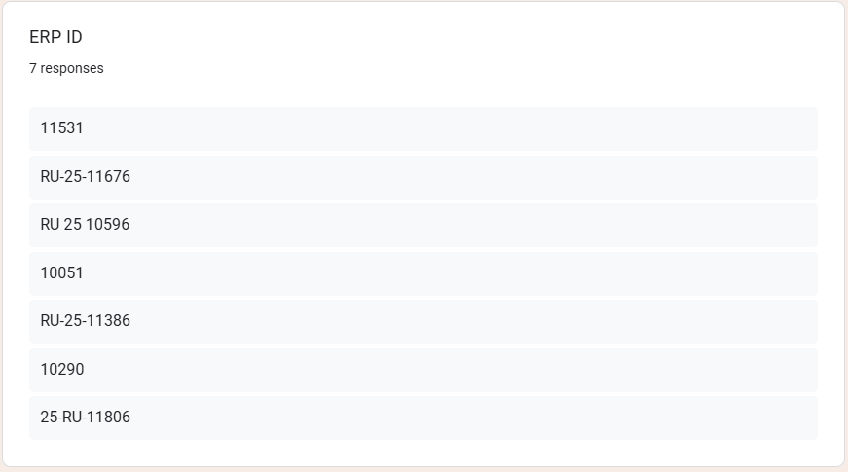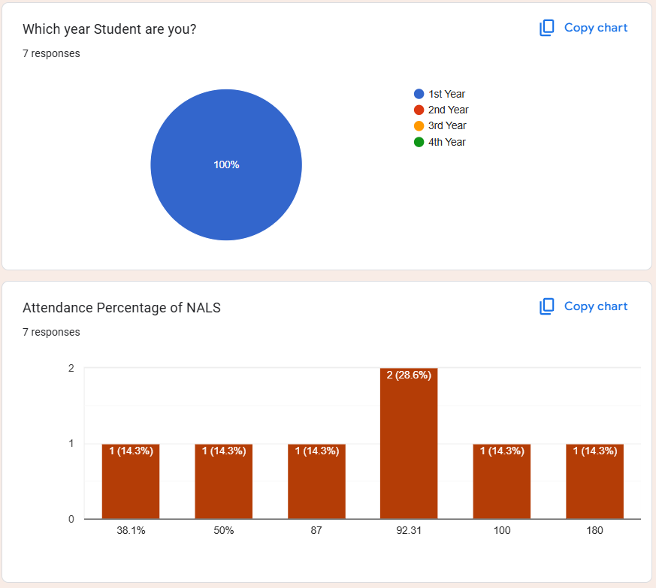

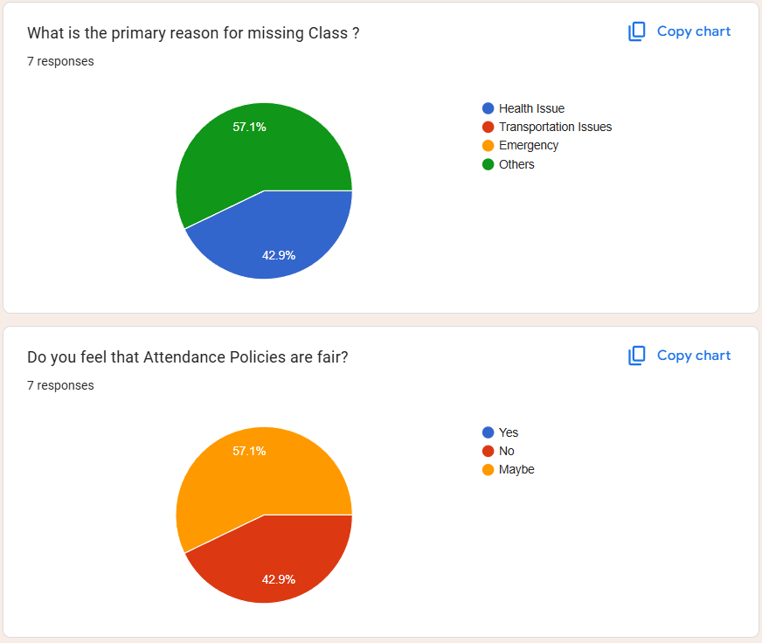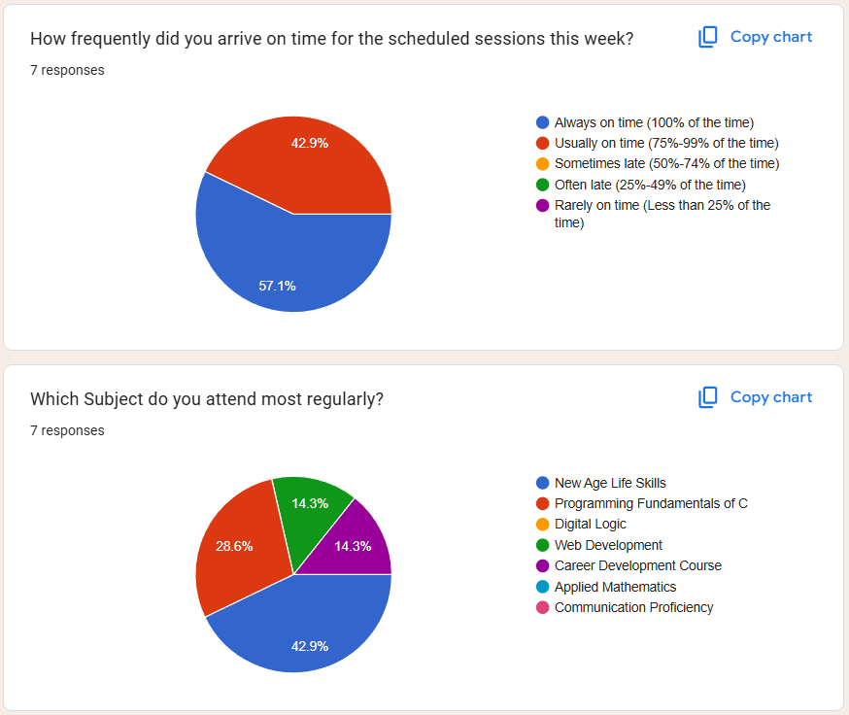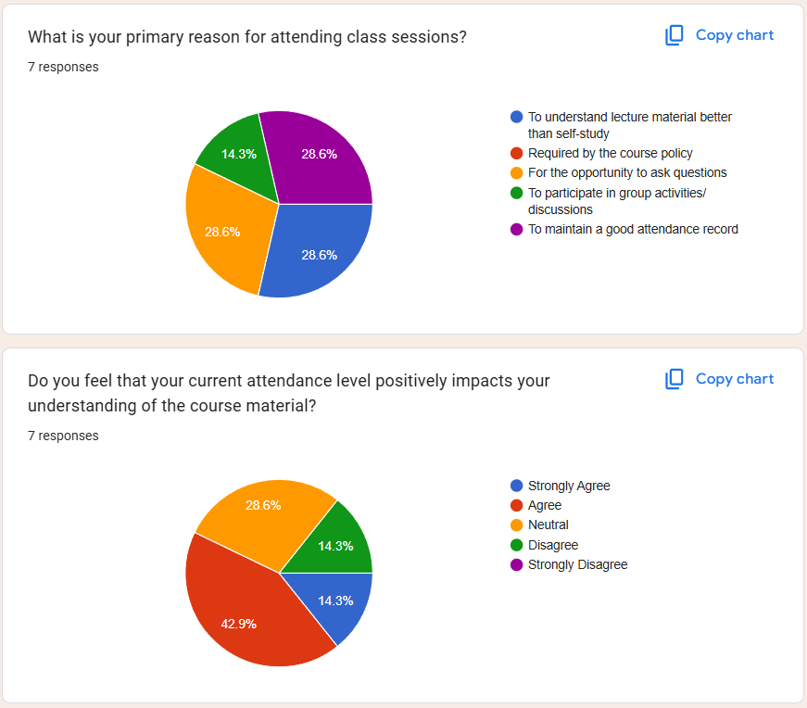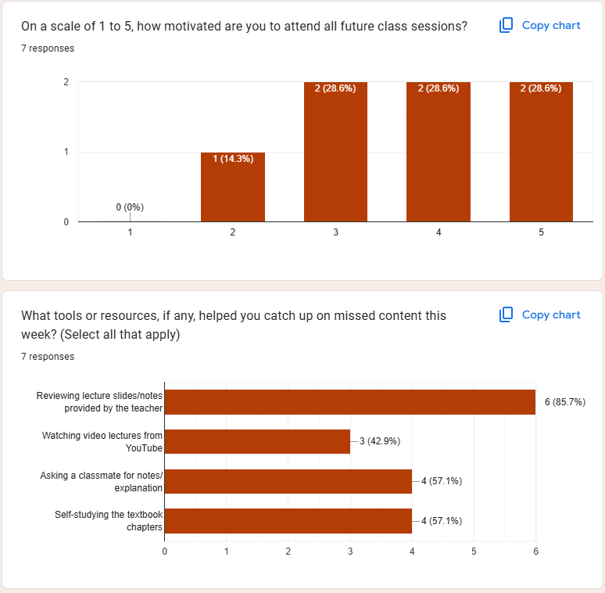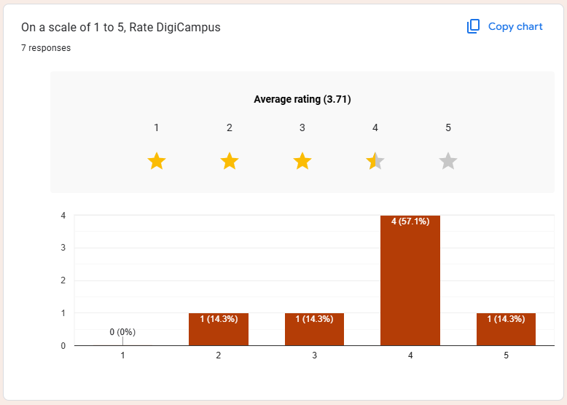

**Practical – 6**

Step 1 = We have to create a Linkedin Profile

Step 2 = Add your Profile Picture and Profile Banner

Step 3 = Add your Education Background

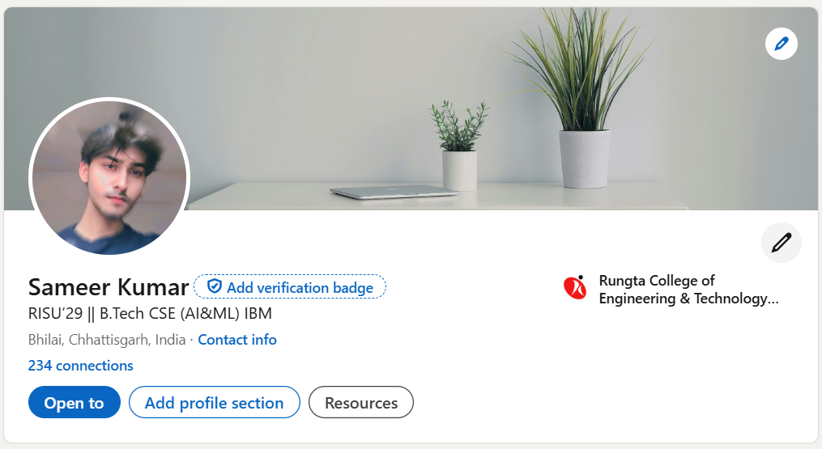

Step 4 = Write Bio About yourself and your Ambition

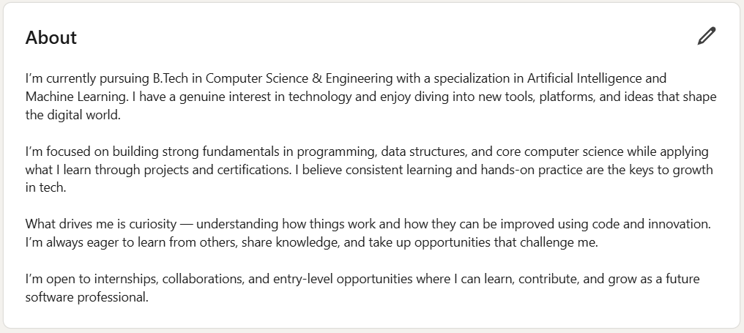

Step 5 = Post about something like Certificates and Events that you’ve attend

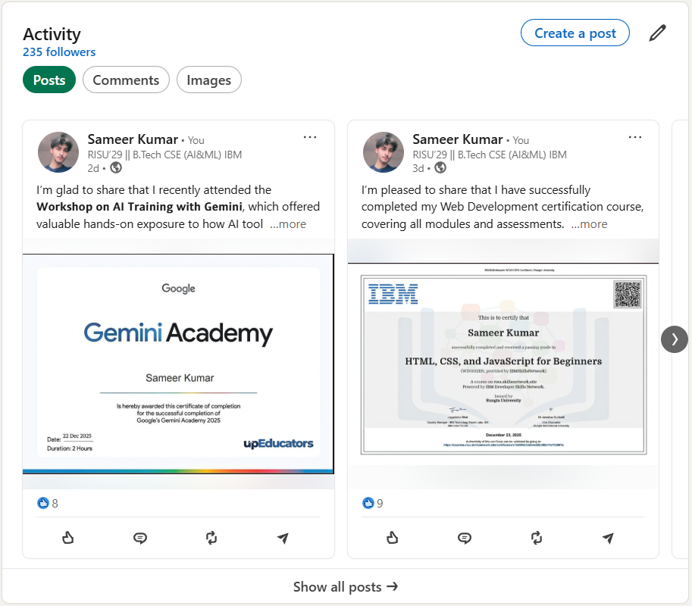

Step 6 = Add your skills that you have

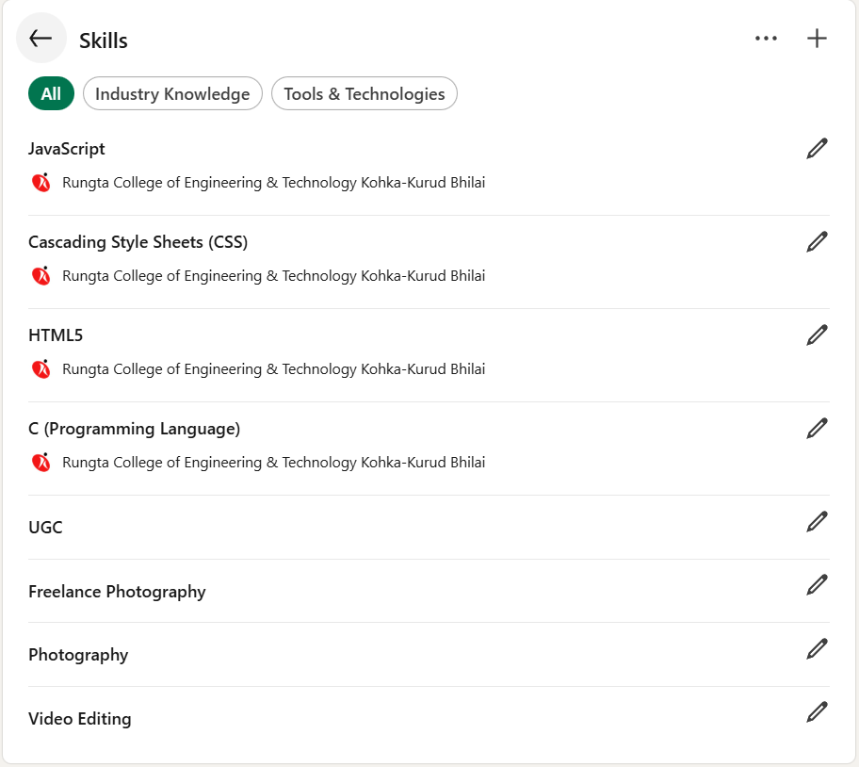

**Practical – 7**

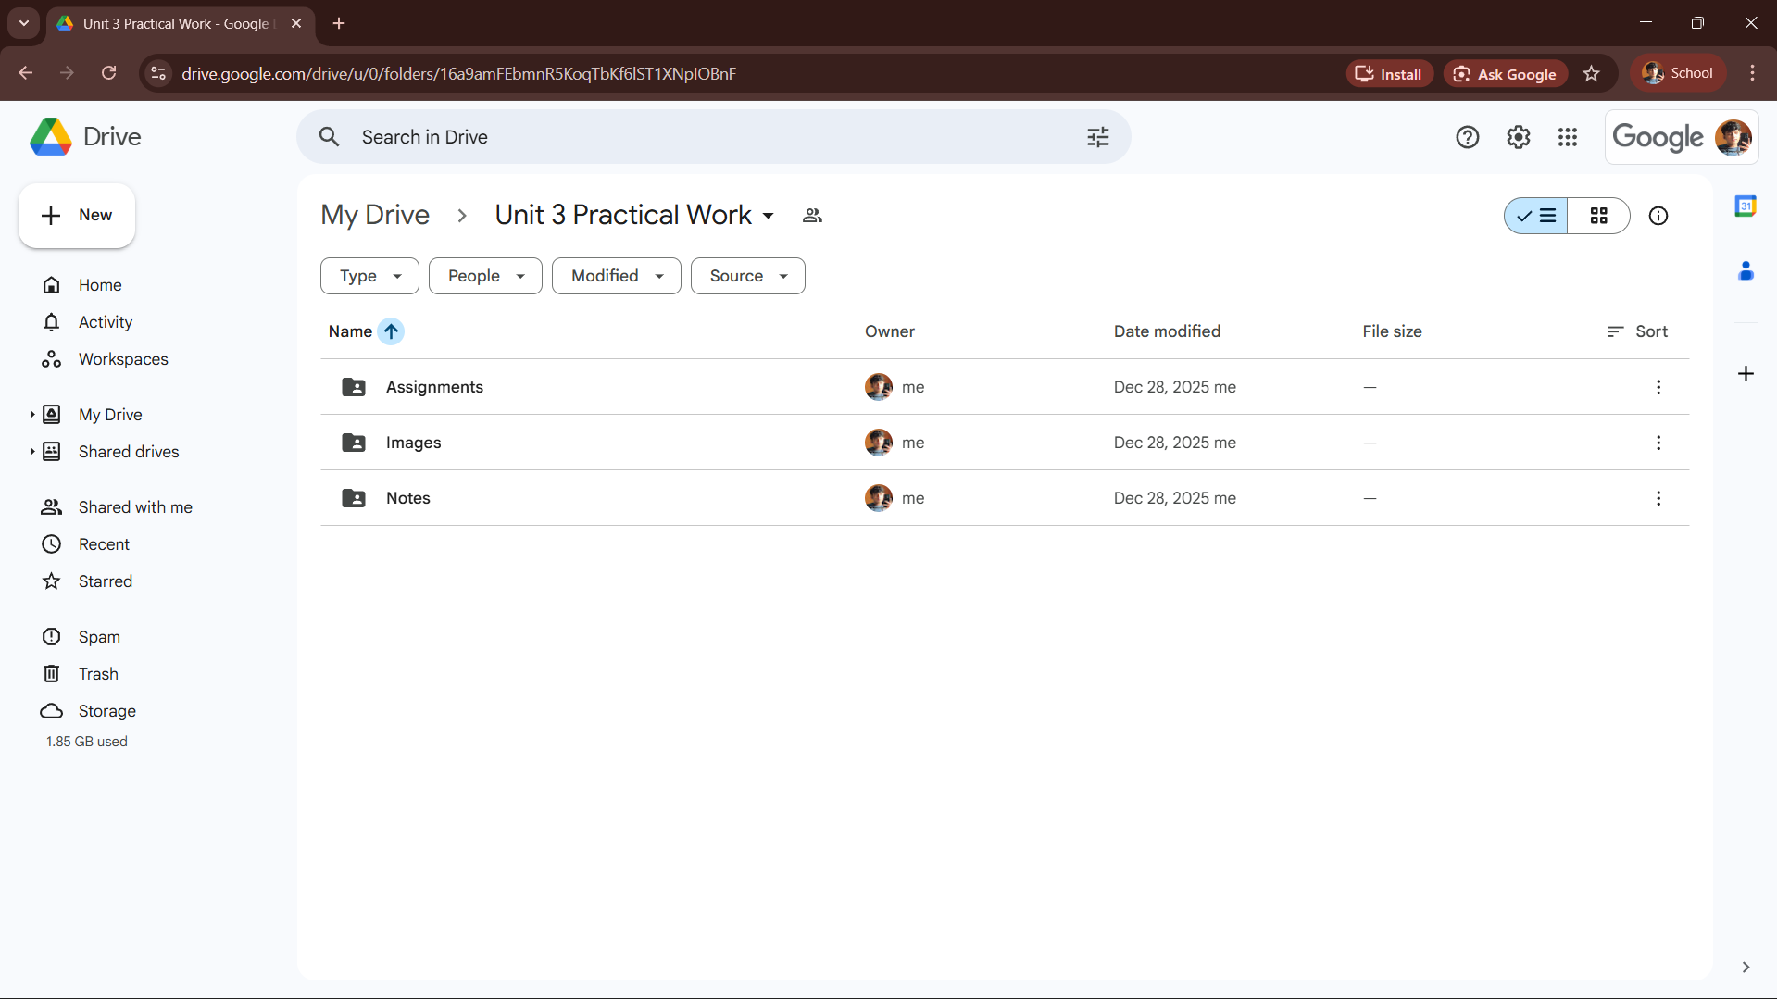

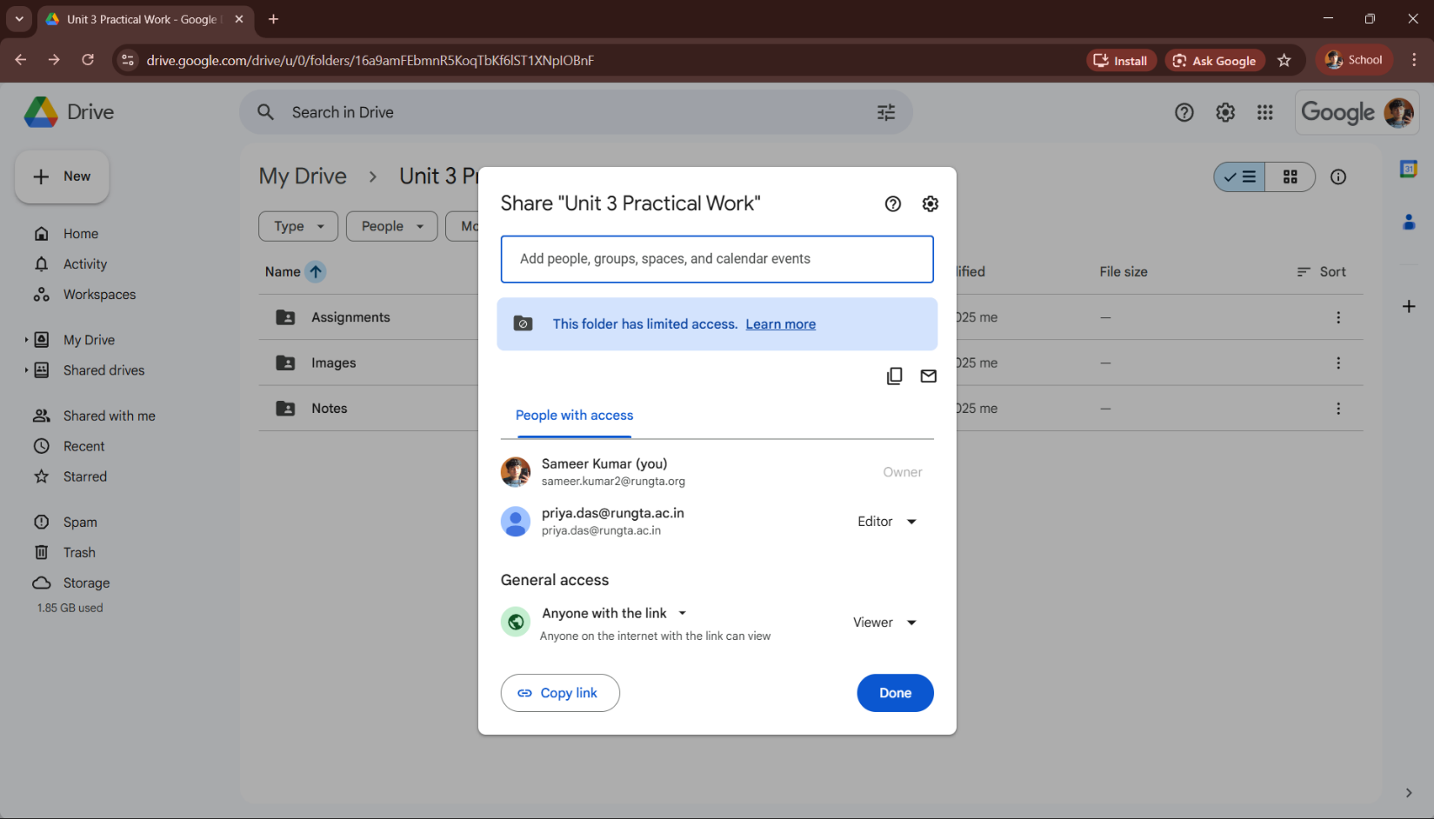**Practical – 8**

“You are shortlisted for a Remote Software Developer role at Google.

Salary: ₹18 LPA.

Pay ₹2,499 as verification fee.

Limited seats.

Pay now to confirm.” ANSWER THE QUESTIONS :- .



**(a)What type of cybercrime is happening here?**

Ans- This is a type of Phishing or Job Scam. It is called Phishing because the scammer is impersonating a reputable company (Google) to "lure" Aman into providing sensitive information (money/bank details). Specifically, it is an Employment/Job Scam, aimed at defrauding money by offering the false promise of a job.

**(b) List 3 red flags that show it is a scam?**

Ans-The following 3 points clearly indicate that this message is a scam:

1. Demand for a Verification Fee: No legitimate and large company (like Google) ever asks candidates for a "verification fee", security deposit, or processing fee to secure a job offer, especially in the initial stages. This is the biggest red flag.

2. Overly Attractive, Vague Offer: An attractive salary of ₹18 LPA is offered, but this offer is made without any formal interview or selection process. Reputable companies, especially Google, do not extend final offers without a rigorous, multi-stage interview process.

3. Urgency for Immediate Payment ('Limited Seats', 'Pay Now'): Scammers often use phrases like "limited seats" or "pay immediately" to create pressure and prevent the victim from thinking clearly. This is a common phishing tactic.

**(c) What should he do to verify if a job offer is real?**

Ans-Aman should take these steps to verify the job offer:

→ Check Google's Official Website: Aman should go directly to Google Careers (Google's official career website) and see if the position (Remote Software Developer) is listed there. If it were a genuine position, it would always be found on Google's own website.

→ Use Official Contact Information:

Instead of replying to the LinkedIn message, he should contact Google's Recruiting department through the email or contact form provided on Google's official website and inquire about this offer.

→ Check the Source of the Message: On LinkedIn, he should check if the profile of the person sending the message is that of a genuine Google employee. He should examine that person's profile to see if they actually work at Google and if their profile looks suspicious (e.g., recently created, very few connections, etc.).

**Practical – 9**

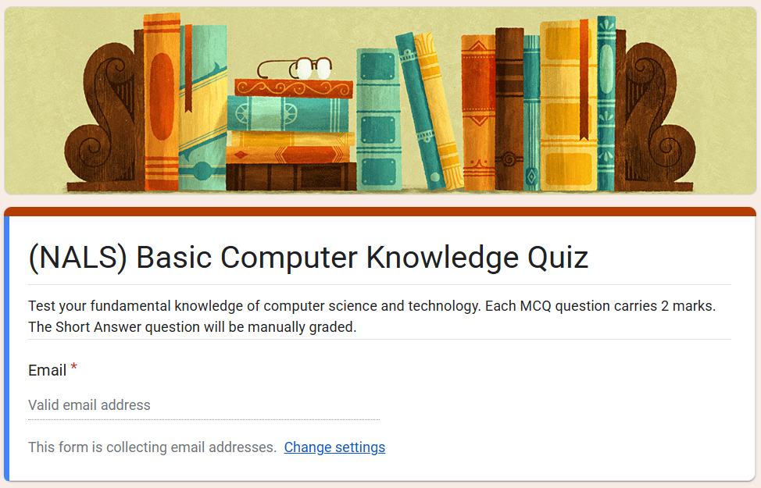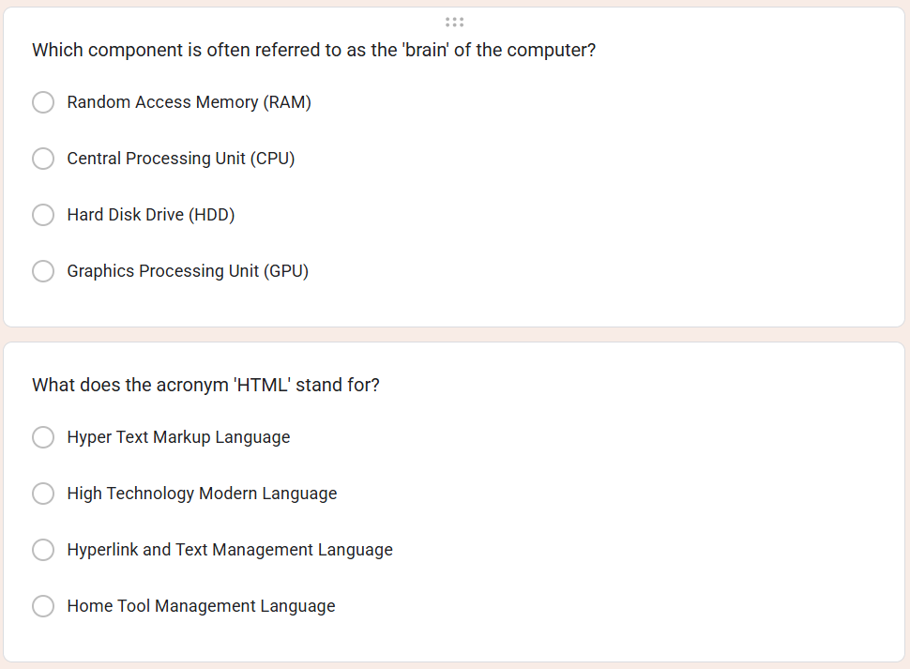

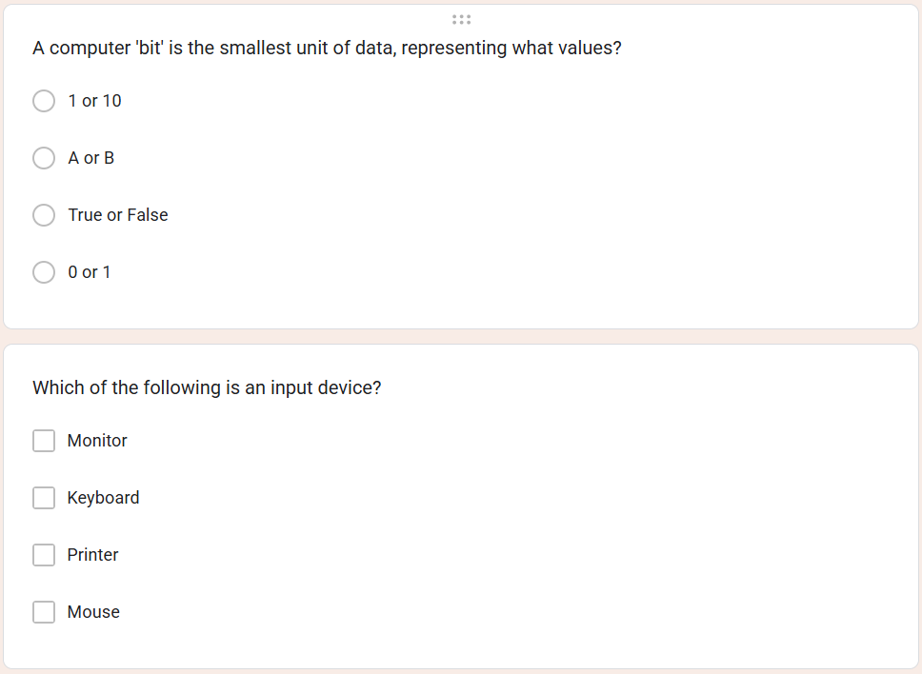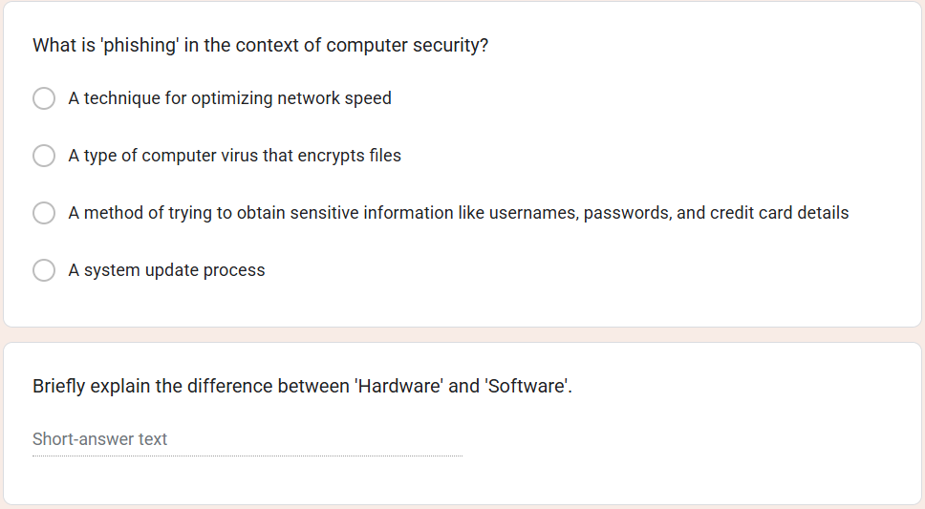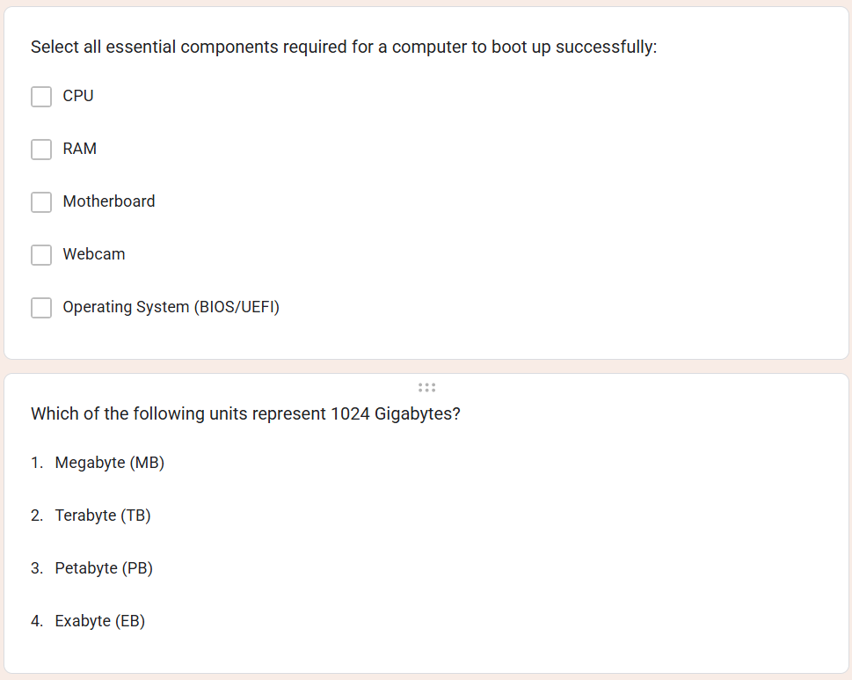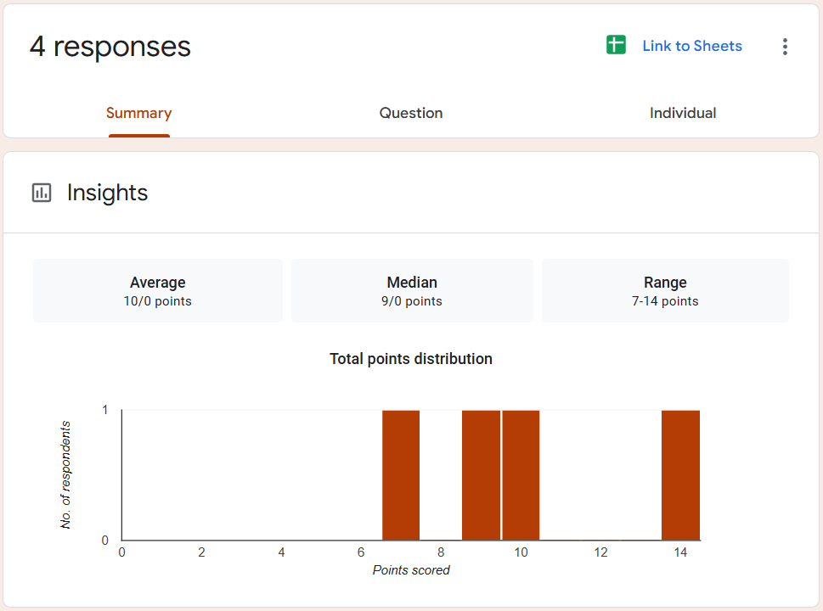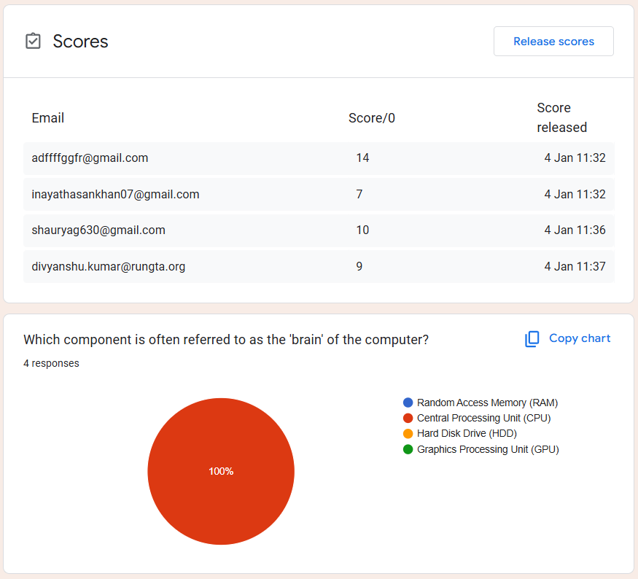

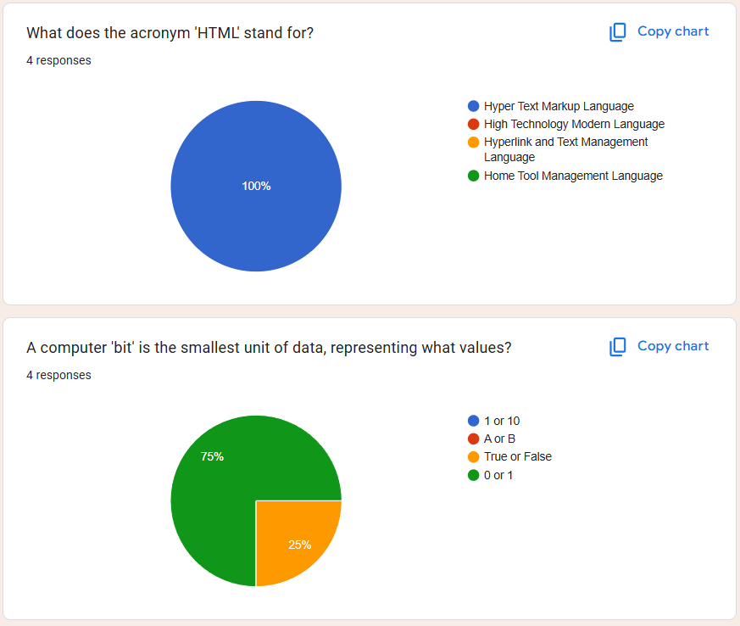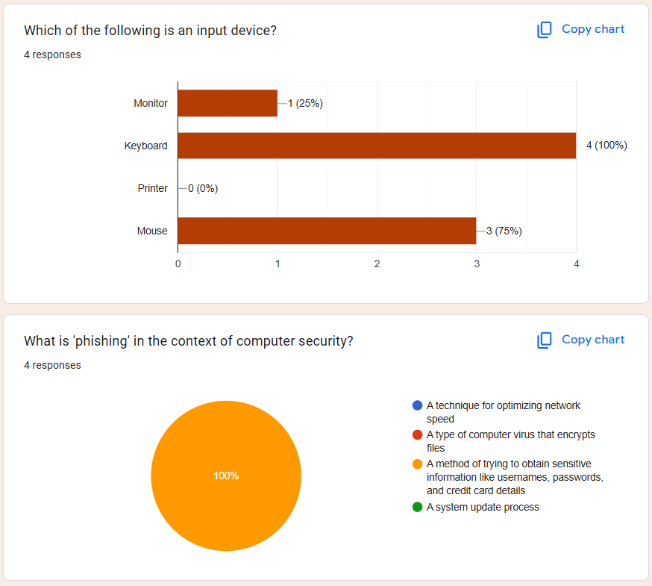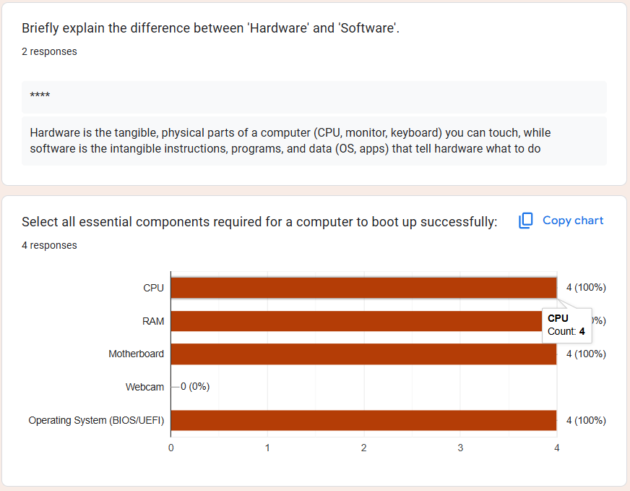

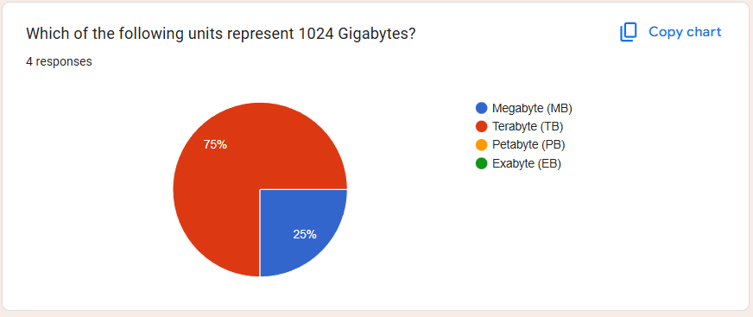

**Practical – 10**

**ChatGPT Generated:**

Online learning has become a strong alternative to offline learning for college students, especially in the digital age. It offers flexibility, allowing students to attend classes from anywhere and manage their time more efficiently. Online platforms provide access to recorded lectures, digital resources, and self-paced learning, which is helpful for revision and skill development. However, offline learning offers face-to-face interaction, better classroom discipline, and stronger peer bonding, which enhance communication skills and motivation. For college students, a balanced approach is often best. While online learning supports convenience and independent learning, offline learning helps build practical skills, teamwork, and real-world academic experience.

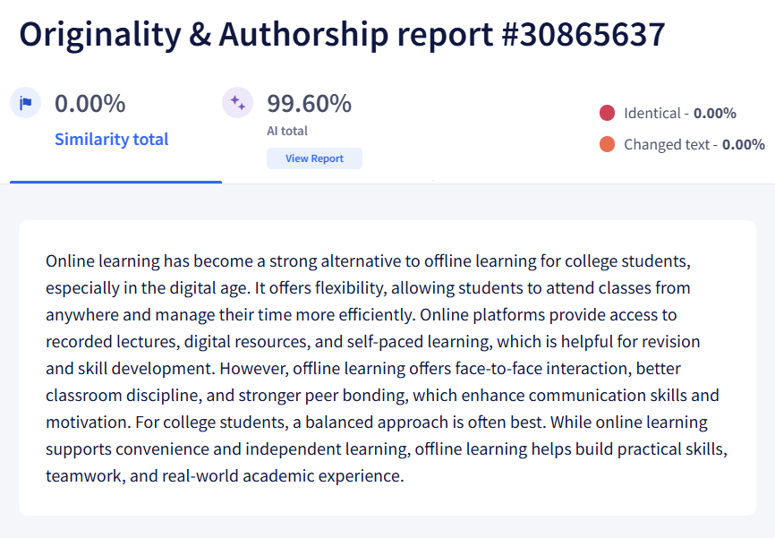

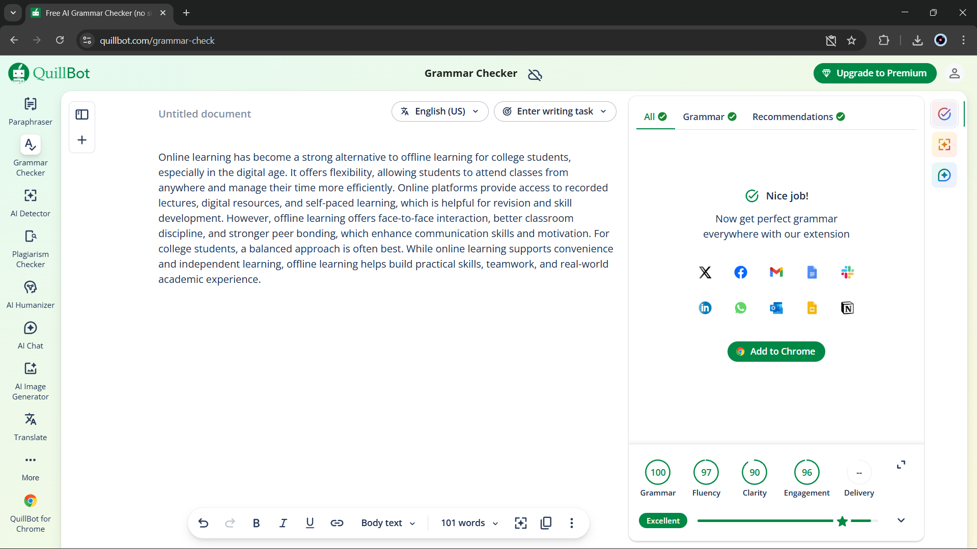

**Rewrite: -**

Online learning is an innovation in learning mode brought by the inevitability of information and communication technology. The present study highlights the benefits of online learning for students. The study was conducted as library research, where previous studies on the benefits of online learning were used as the data source. The study revealed that online learning is argued to have positively affected students' autonomy, motivation, and collaboration skills while providing flexible learning for the learners. The abundance of online sources, tools, and networking enables learners to navigate their learning. These results imply that teachers, educators, and students should embrace online learning and its supporting applications to improve learning processes and outcomes. The present study contributes to the limited literature on a general overview of online learning benefits seen from the learners' side.

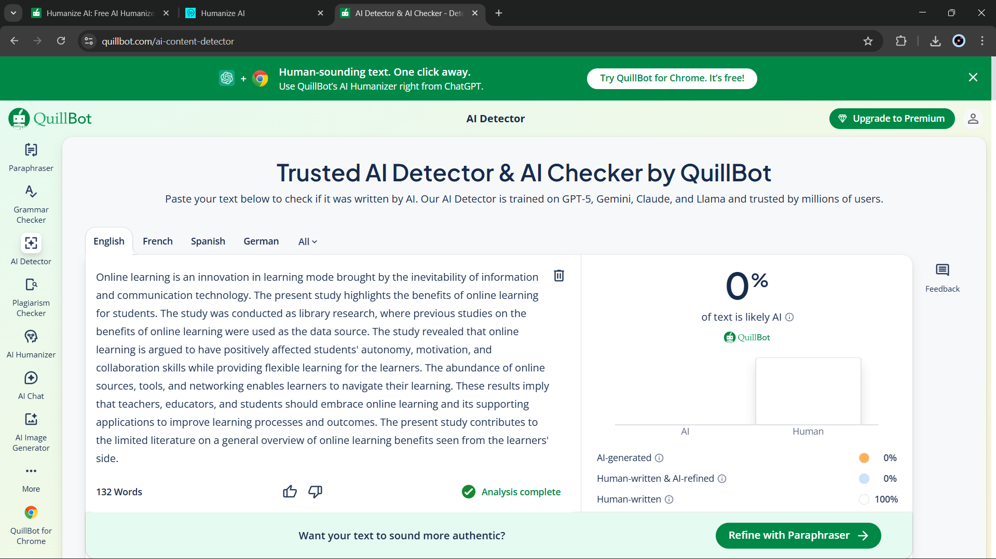

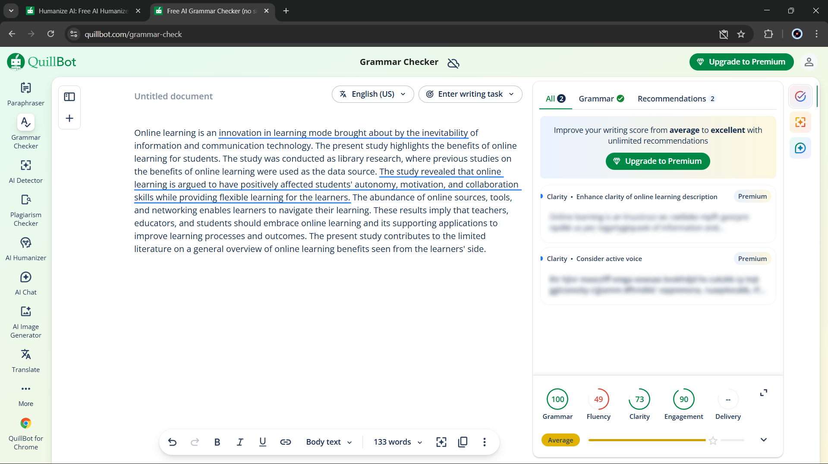

**Practical – 11**

Handwritten: -

“Will AI replace jobs or change them?”

As we live in the era of AI, the most asked question is whether AI will replace our jobs. My answer to this question is that as we progress through new technology and the era of innovation, an AI will more likely change the job rather than replace it. While AI can do lots of work in a very small amount of time without getting tired, some jobs require human creativity, emotional intelligence, critical thinking, and moral judgment—skills that AI doesn't have. For example, AI can quickly analyze medical data that is necessary for human doctors to make accurate diagnoses, provide patient care, and inform decision-making. AI is a tool that can help us do our tasks in a much more efficient and productive way. AI will reduce some low-skill jobs, creating challenges for workers. However, it will create new jobs such as AI development, data analysis, cybersecurity, and AI ethics. Overall, AI will not replace our jobs; it represents the shift in the nature of work, making adaptability and continuous learning much more important than ever.

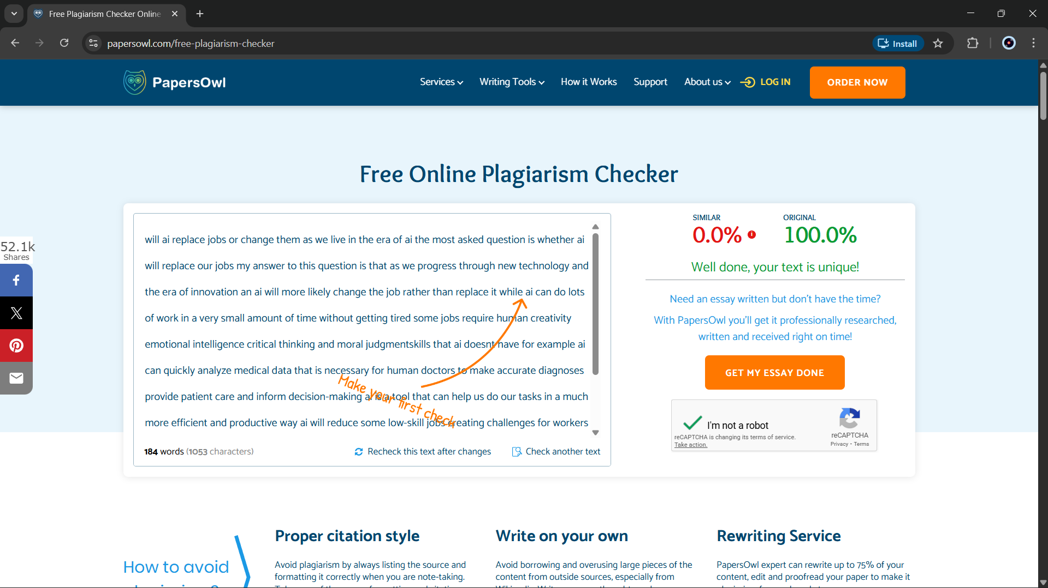

AI Generated: -

Artificial Intelligence is more likely to change jobs than completely replace them. While AI can automate repetitive and routine tasks, many roles still require human creativity, emotional intelligence, critical thinking, and ethical judgment—skills that machines cannot fully replicate. For example, AI can assist doctors by analyzing medical data, but human doctors are still essential for diagnosis, decision-making, and patient care. Similarly, AI tools help teachers, designers, and programmers work more efficiently rather than eliminating their roles. At the same time, AI will reduce demand for certain low-skill or repetitive jobs, creating challenges for workers who lack opportunities to reskill. However, it will also generate new careers in areas such as AI development, data analysis, cybersecurity, and AI ethics. Overall, AI represents a shift in the nature of work, making adaptability and continuous learning more important than ever.

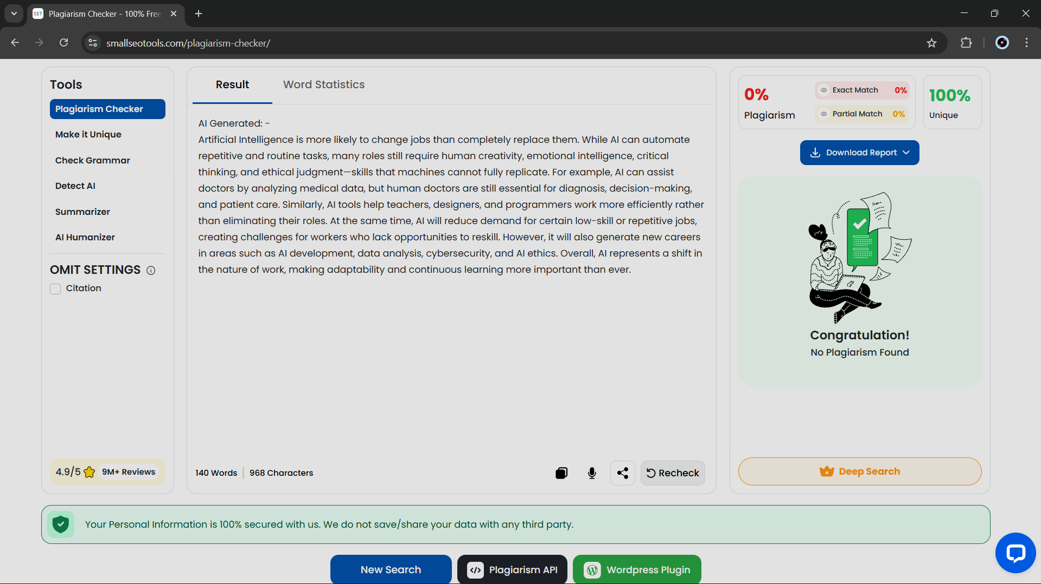

**Practical – 12**

i. Combined study guide: -

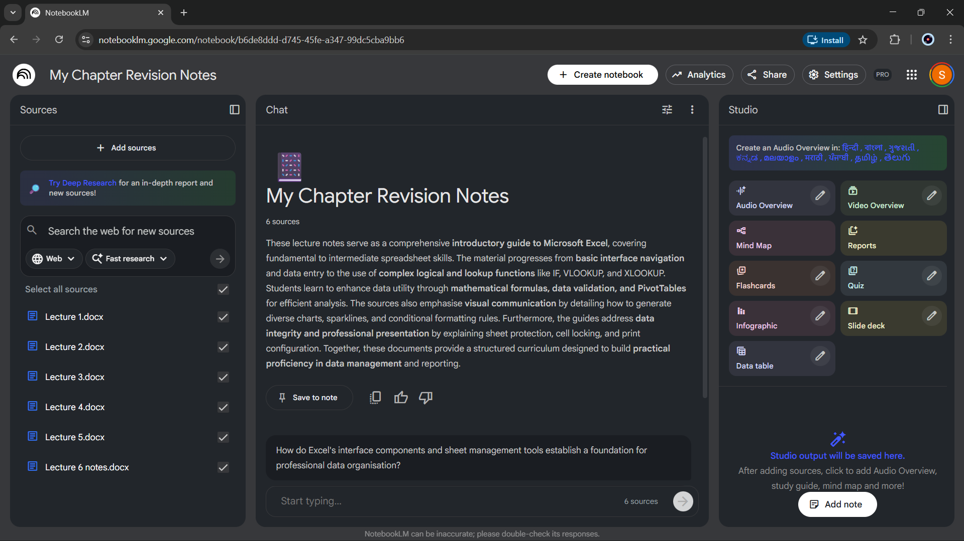

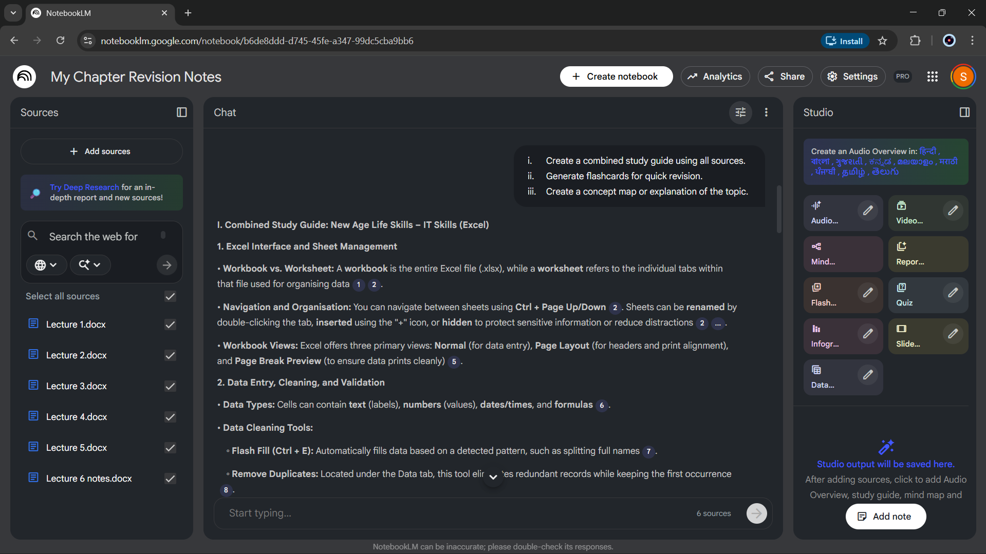

ii. Flashcards :-

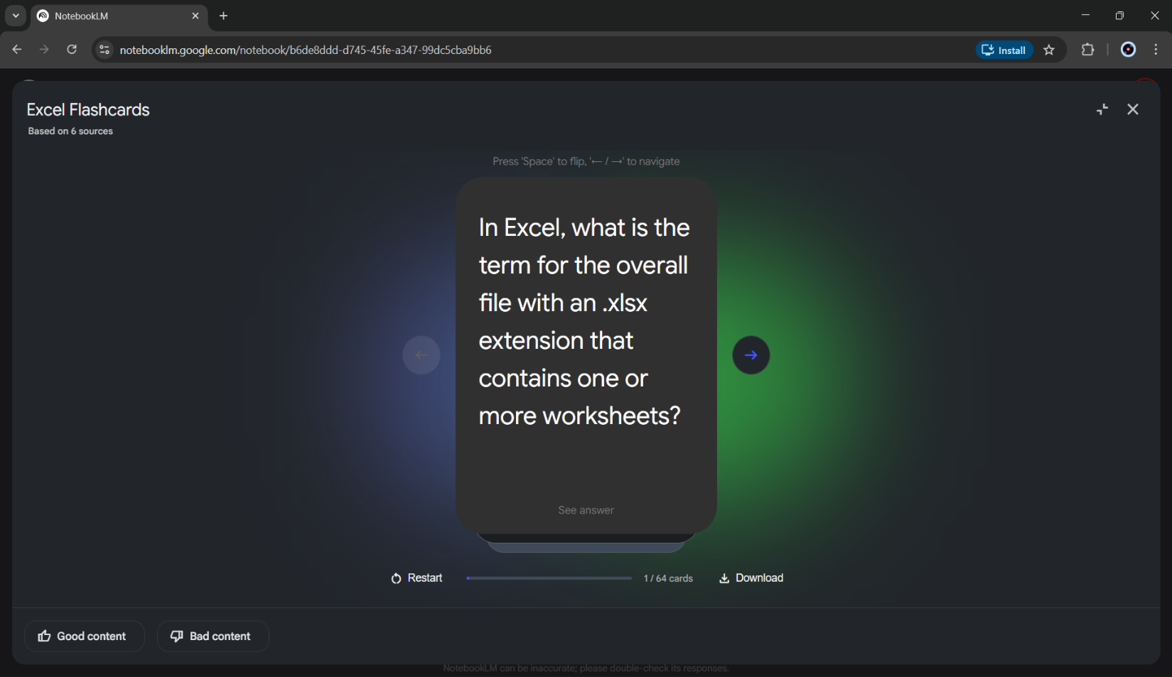

iii. Concept map / explanation: -

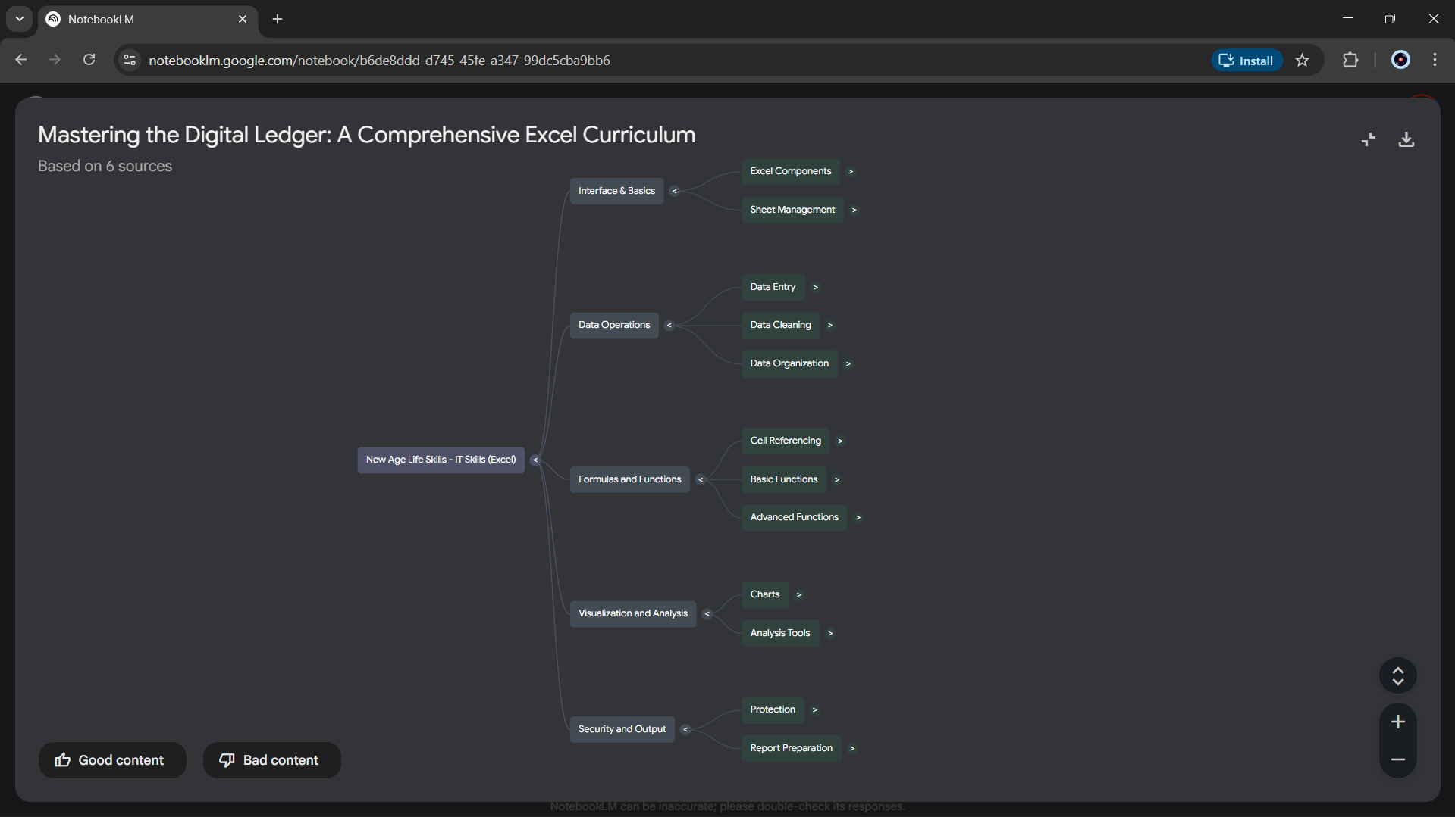

**Practical – 13**

Student Data :-

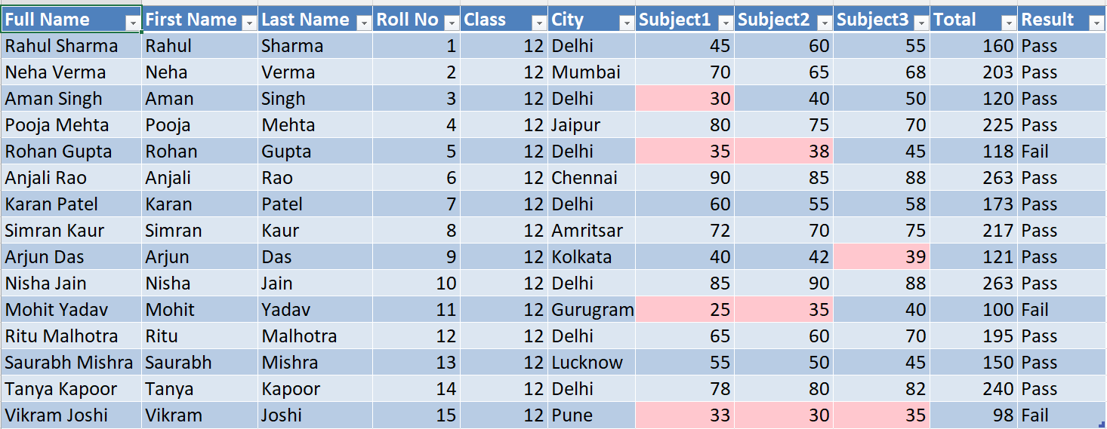

Marks Analysis :-

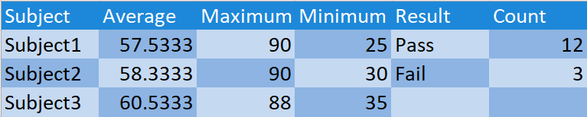

Charts :-

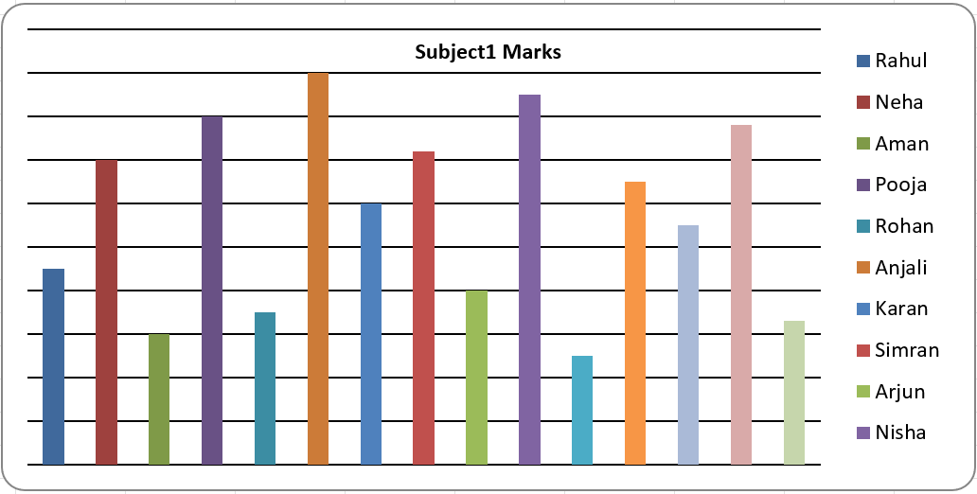

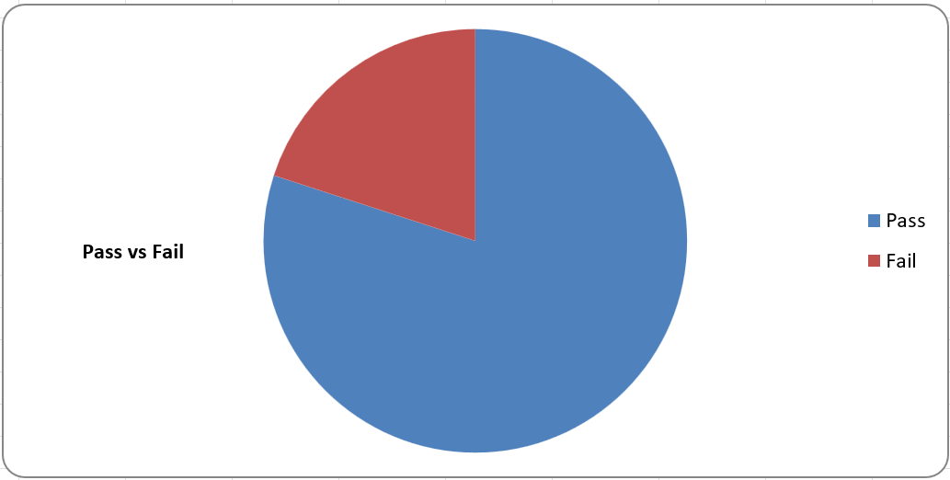

**Practical – 14**

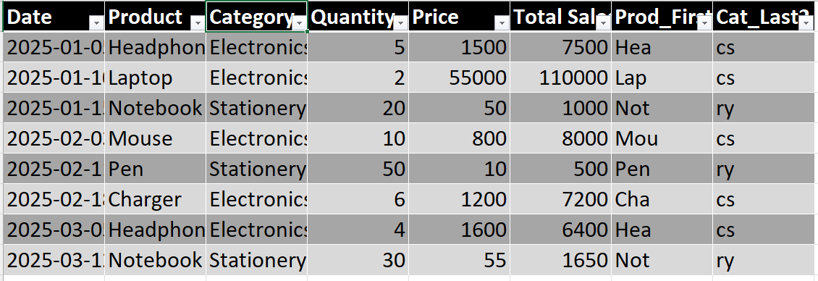

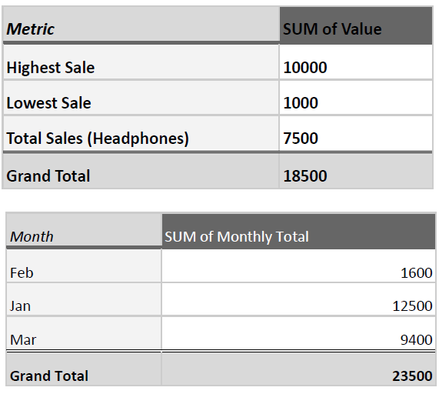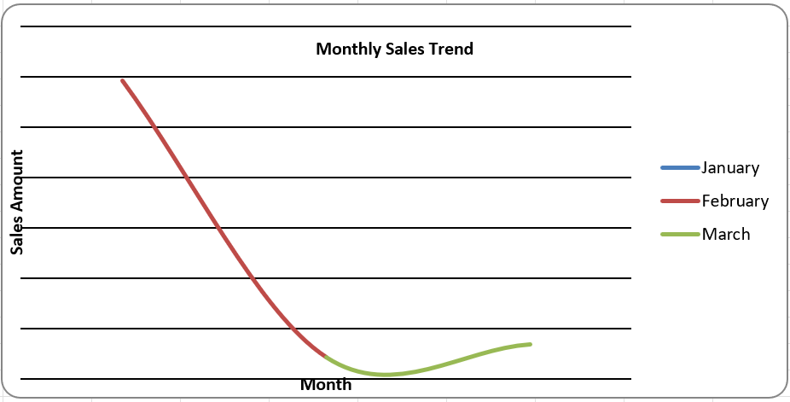

**Practical – 15**

Expenses :-

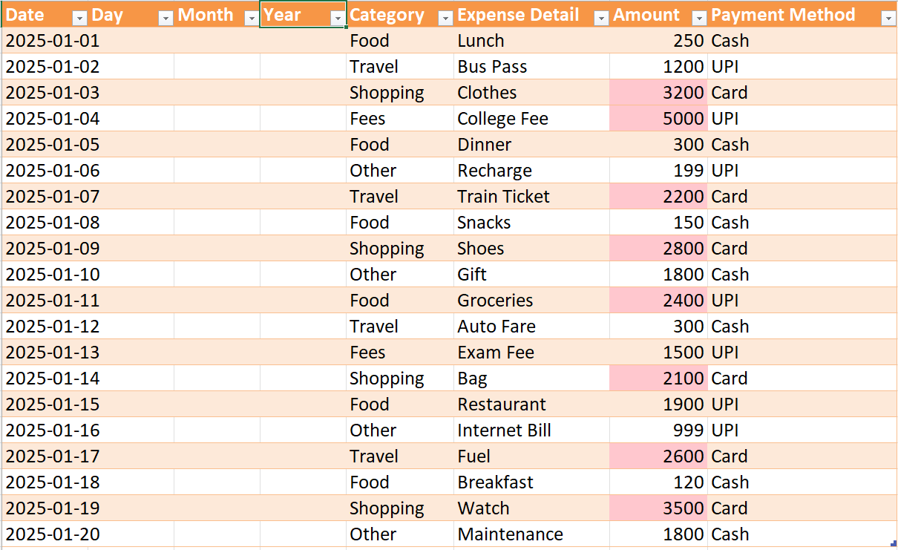

Budget :-

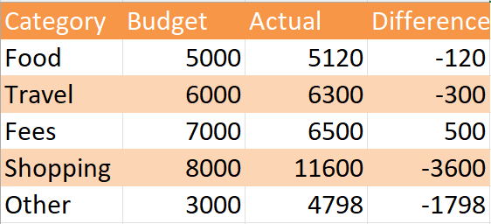

Charts :-

